Abstract

A deceptive isometric puzzler. Not everything is as it seems with optical illusions to keep players on their toes

BEANS  
Cross Platform Development

Author: Ruben Antao

# Change Log

Updates made to the document should be described below.

|  |  |  |  |
| --- | --- | --- | --- |
| Version | Author | Date of change | Description |
| 0.0.0 | AIE | 27/08/2020 | Initial Template created |
| 0.1.0 | Madcrafty | 27/08/2020 | Simple demo project |
| 0.1.5 | Madcrafty | 28/08/2020 | Made some new levels with moving platforms |
| 0.2.2 | Madcrafty | 03/09/2020 | added menu system, added URP |
| 0.3.2 | Madcrafty | 07/09/2020 | Made some new levels, texturing on pressure plates and a follow camera script |
| 0.4.2 | Madcrafty | 08/09/2020 | Camera Lerp works with any movement and added Birds eye view mode with m, remodelled level select menu, Improved Exit script with next level toggle, Added player activation toggle to moving platforms |
| 0.4.3 | Madcrafty | 09/09/2020 | Fixed Post processing package issues |
| 0.4.6 | Madcrafty | 09/09/2020 | Input manager and post processing fixed; added controller support |
| 0.5.2 | Madcrafty | 10/09/2020 | mobile functionality, fixed minor issue with exit door, added stage to main menu |
| 0.5.3 | Madcrafty | 11/09/2020 | Made aesthetic changes to the main menu |
| 0.5.5 | Madcrafty | 11/09/2020 | fixed level 6 to have a more consistent solution |
| 0.6.0 | Madcrafty | 11/09/2020 | fixed menu with scaling buttons and backdrop, made moving platforms have blue colour |
| 0.6.3 | Madcrafty | 14/09/2020 | menu works with controller now (a little weird when switching from KB to Controller) |
| 0.6.5 | Madcrafty | 15/09/2020 | improved controls, platforms change colours depending on if they are moving |
| 0.6.6 | Madcrafty | 16/09/2020 | fixed inverted menu controls for web |
| 0.6.8 | Madcrafty | 17/09/2020 | added installer |
| 0.6.9 | Madcrafty | 17/09/2020 | Added post-processing and backdrop for levels |

Contents

Change Log 1

1.0 Development Environment 3

1.1 Game Engine 3

1.2 Source Control 3

1.3 Third-Party Libraries / assets 3

2.0 Game Overview 3

2.1 Genre 3

2.2 Camera Perspective and Movement 3

2.3 Platform 3

2.4 Technical Goals 4

2.5 Game Objects and Logic 4

3.0 Controls 4

3.1 Windows / Web 4

3.2 Console / Xbox 4

3.1 Android / Touch 4

4.0 Mechanics 4

5.0 Graphics 5

6.0 Game Flow 5

6.1 ‘Mission’ / ‘Level’ structure 5

6.2 Objectives/Goal 5

8.0 Interface 5

8.1 Menu 5

8.2 UI/HUD 5

9.0 Progress report and feedback Meeting Minutes 6

Friday 4th September 6

Wednesday 9th September 6

Thursday 10th September 6

Friday 11th September 7

# Development Environment

## Game Engine

Unity 2019.3.6f1 (Enterprise/Personal edition): I chose Unity as I am more familiar with it than other game engines and I chose this version for my project as it was the latest install on the computers at school without requesting admin permission to get a newer version.

## Source Control

Link to github repo: https://github.com/Madcrafty/Unity_ISOPUZZLE

## Third-Party Libraries / assets

|  |  |  |
| --- | --- | --- |
| Asset Name  License | URL | Reason for use |
| Pro-builder |  | To more easily design levels |
| Universal Render Pipeline |  | Thought it was a requirement for post processing package |
| Post Processing |  | Make colours in the level pop a little more |
| Input System |  | Better control over what action corresponds to what function (Useful for PC and Console platforms) |

# Game Overview

You play as a little bean who is in a simulated environment designed to enhance bean kind. This simulation is designed to test the beans ability to solve puzzles and make him the smartest and most adaptable bean.

## Genre

Isometric puzzler:

This genre is all about solving puzzles from the unique isometric perspective which makes it difficult to perceive 3D space. This means most of the puzzles revolve around special awareness, Understanding the limits of your perspective and finding the path… TO VICTORY.

## Camera Perspective and Movement

Describe

## Platform

The only manual alterations I have to make is for the web build of the game where for some reason unknown to me the vertical analogue stick controls are inverted. I have to invert the controls for menuing and character so when it gets inverted for web, it becomes normal.

## Technical Goals

* Player movement
* Interactable objects
* Camera control
* UI design
* Scene Loading

## Game Objects and Logic

* Door:
  + Open: When all the pressure plates are pressed (or any specific condition really)
  + Load Scene: When the player enters the load zone
* Moving Platform:
  + Follow path: Moves to the next point in its path
  + Player trigger: Moves only when the player steps on them
  + Loop: Loop back through the path when they reach the end
* Pressure Plate:
  + Player trigger: Only activates when the player steps on it
  + Activates door: Allows player to open level door
* Camera:
  + Static: stays in one spot
  + Follow target: if target moves lerp to the targets new position + offset
  + Birds-eye: see whole map when pressing a button
* Player:
  + Move: when appropriate bindings are pressed
  + Pause: when in pause screen

# Controls

## 3.1 Windows / Web

WASD: to move

Escape: to pause

M: to view whole map

## 3.2 Console / Xbox

D-Pad/Left-stick: to move

Start/Options: to pause

South Button: to view whole map

## 3.1 Android / Touch

On-screen buttons:

# Mechanics

A list of intended core game mechanics. I.e., what the player can do and how they achieve this, and what this will trigger in the game. For example, shooting enemies is a core mechanic in an FPS.

* **Moving**You only move one block at a time, but it isn’t restricted. You can move to corners and edges with slopes and running into offset blocks
* **Respawning**

There is a giant box around the whole map. If the player falls out of this box the game will restart the level

* **Moving platforms**They have a set path and have a variety of settings mentioned in 2.5:
* **Pressure plate**Also mentioned 2.5:

## Hazards

The only hazard is gaps in the terrain and lack of walls

## Obstacles

Optical illusions that mislead the player and pressure plates that are required to activate to complete the level

# Graphics

This game utilises an isometric camera from above (about 30o angled down) which allows for the optical illusions that create dilemmas/twists for the player. I use some post-processing to add a little flare to the game, mostly to experiment, but also to add a bit of visual complexity because the assets themselves are a bit too simple. I kept the graphics simple primarily out of laziness but also it has a nice experimental feel to these stages, almost clinical nature like portal where you have simple puzzles to solve.

# Game Flow

## ‘Mission’ / ‘Level’ structure

Levels 1&2 introduces the basics; door, pressure plates, character the pure basics

Level 3 add complexity; making a maze to explore and adding ramp

Level 4 add more; add moving platform

Level 5 MOORE; got some ramps, platforms and an optical illusion

Level 6; emphasis illusions

Level 7 expand scale; Have a larger level

## Objectives/Goal

The players Object in every level is to press all the pressure plates to open the door and get to the end of the level. Their progress isn’t tracked.

1. Levels

If any of the Levels require specific behaviours, describe those here. UML chats provided if applicable.

Level tiling tool use identified if relevant, use by designer discussed, how was it built

# Interface

Make sure to address the differences needed per platform.

## Menu

What are the menu options, how is it presented to the player? Provide wireframe.  
How does this work for each input device chosen (keyboard/mouse, controller, touch) 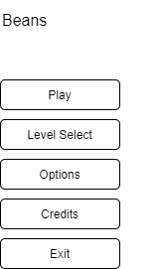

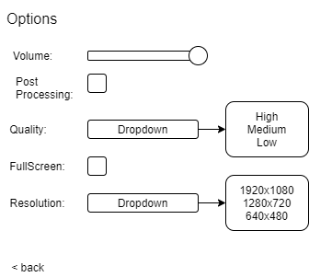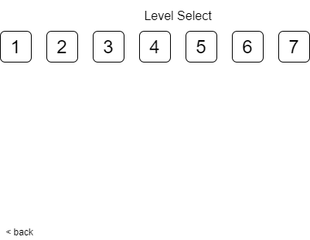

*

*

* =

Not visible on mobile or console

## UI/HUD

Only visible on Mobile version

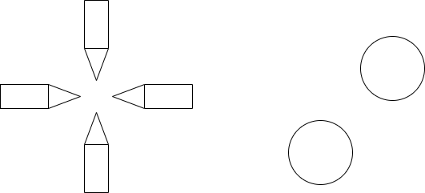

Full map view

Pause

D-Pad

# Progress report and feedback Meeting Minutes

## Friday 4th September

Describe state of project

* Just added Post processing & URP
* Have some levels

Feedback from teacher and peers:

* Describe
* Describe
* Describe

Action Items:

* Describe
* Describe
* Describe

## Wednesday 9th September

Describe state of project

* Thing
* Thing

Feedback from teacher and peers:

* Describe
* Describe
* Describe

Action Items:

* Describe
* Describe
* Describe

## Thursday 10th September

Describe state of project

* mobile functionality, fixed minor issue with exit door, added stage to main menu

Feedback from teacher and peers:

* Describe
* Describe
* Describe

Action Items:

* Describe
* Describe
* Describe

## Friday 11th September

Describe what has been done since last time

* fixed menu with scaling buttons and backdrop, made moving platforms have blue colour
* Made aesthetic changes to the main menu

Feedback from teacher and peers:

* Describe
* Describe
* Describe

Action Items:

* Describe
* Describe
* Describe